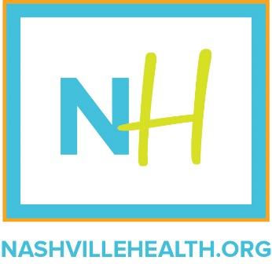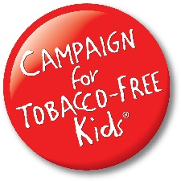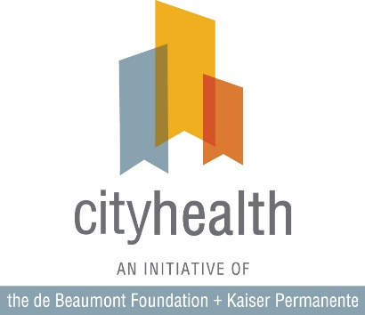
Contact: Molly Sudderth
msudderth@nashvillehealth.org

Tennessee Statewide Tobacco Poll
Social Media Messaging
Twitter
- New poll shows 63% of Tennesseans support raising age for tobacco sales from 18 to 21.
https://nashvillehealth.org/tennesseans-support-significant-tobacco-and-vape-policy-changes/
#T21 #SayNo2Tobacco #tobaccofreekids #healthynashville #healthierTN

- 86% of Tennesseans believe the age to buy vaping products and e-cigarettes should be 21. https://nashvillehealth.org/tennesseans-support-significant-tobacco-and-vape-policy-changes/
#T21 #SayNo2Tobacco #tobaccofreekids #healthynashville #healthierTN

- 78% of #TN voters support state law to make all indoor public spaces smoke free. https://nashvillehealth.org/tennesseans-support-significant-tobacco-and-vape-policy-changes/
#SayNo2Tobacco #healthynashville #healthierTN

- 80% of Tennesseans support putting at least $4M of state’s tobacco revenue funds to prevention programs. https://nashvillehealth.org/tennesseans-support-significant-tobacco-and-vape-policy-changes/
#healthierTN #healthynashville

- Thanks @SenShaneReeves for working to raise the age to buy tobacco and vaping-related products from 18 to 21! #T21 #tobaccofreekids #healthierTN

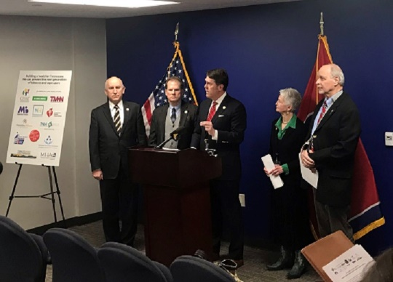

Health Statistics:
- 95% of adults who smoke started before age 21. Raising the age to purchase prevents the next generation of tobacco users. #SayNo2Tobacco #T21 #tobaccofreekids #healthierTN #healthynashville

- Raising tobacco purchase age to 21 will lower smoking rate by 12% & related deaths by 10% meaning 4.2 million fewer years of life lost. #T21 #healthierTN

- #TN’s smoking rate is among worst in US and leading cause of preventable death in TN. #SayNo2Tobacco #healthierTN

- Over 20% of #TN high school students say they used some kind of tobacco or vaping-related product in the last 30 days. #SayNo2Tobacco #T21 #tobaccofreekids

- Current smoking rates show 125K children alive in TN right now will die from tobacco use, which kills more people each year than alcohol, car crashes, drugs, AIDS, murder & suicide combined. #tobaccofreekids #SayNo2Tobacco #healthierTN

Cost Statistics:
- Smoking in #TN results in $2.6B in health care costs. #SayNo2Tobacco #healthierTN

- Smoking-caused productivity losses in #TN equal nearly $3.6B. #SayNo2Tobacco #healthierTN

Facebook
Post #1

NashvilleHealth partnered with @TobaccoFreeKids and CityHealth, an initiative of the @deBeaumontFoundation and Kaiser Permanente, to commission a statewide poll that shows strong support for changes to tobacco and vaping-related policies in Tennessee. Read it here.

https://nashvillehealth.org/wp-content/upload/2019/03/TN-Statewide-Poll-3-25-19.pdf

Post #2

A recent statewide poll shows that 63% of Tennesseans support increasing the minimum age for tobacco sales from 18 to 21 and 86% believe vaping products and electronic cigarettes should be included.

https://nashvillehealth.org/tennesseans-support-significant-tobacco-and-vape-policy-changes/

Post #3

A statewide poll conducted by @PublicOpinionStrategies shows that 78 percent of voters are in favor of a state law to make all indoor public spaces smoke free and 80 percent support dedicating at least $4 million of the state’s tobacco revenue funds to prevention programs. Bipartisan support of these issues spans the state.
https://nashvillehealth.org/tennesseans-support-significant-tobacco-and-vape-policy-changes/

Instagram

Post #1

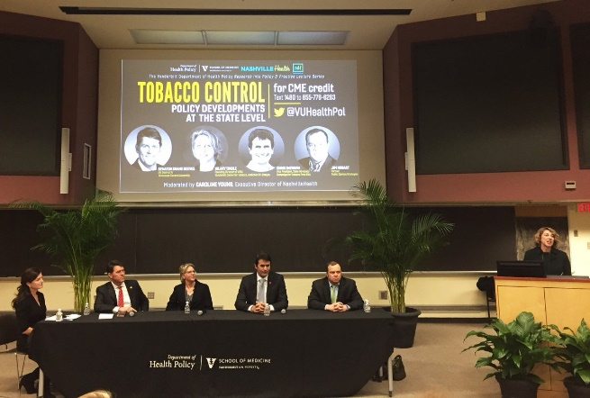

Copy:
Great discussion with former State Senator Shane Reeves, Chris Sherwin, Dr. Hilary Tindle, and Jim Hobart about tobacco and vaping-related policy shifts in Tennessee.
#healthierTN #healthynashville #SayNo2Tobacco #tobaccofreekids #TN

Post #2

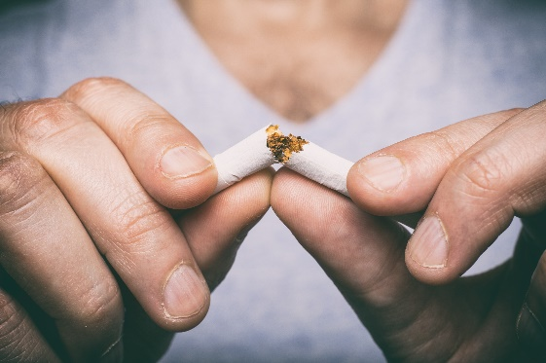

Copy:
A recent statewide poll shows that 63% of Tennesseans support increasing the minimum age for tobacco sales from 18 to 21 and 86% believe vaping products and electronic cigarettes should be included.

#healthierTN #healthynashville #SayNo2Tobacco #tobaccofreekids #TN

